Introduction to Virtualization and Cloud Computing
1. Introduction to Virtualization
- What is Virtualization?
  - Virtualization is the creation of a virtual version of hardware, allowing multiple operating systems to run on a single physical machine.
- Types of Virtualizations
  - Server Virtualization: Multiple virtual servers on one physical machine.
  - Storage Virtualization: Combining multiple physical storage devices into a single virtual unit.
  - Network Virtualization: Abstracting network resources into a manageable virtual framework.
- Key Benefits:
  - Efficient resource utilization
  - Cost savings
  - Scalability
  - Simplified management
Deep Dive Knowledge:
- Virtualization uses a hypervisor (like VMware or VirtualBox) to manage VMs.
- Popular tools include KVM, Xen, and Microsoft Hyper-V.
- Real-time Example: A company can run a legacy Windows app on a Linux server using virtualization.
Simple Explanation:
- Think of virtualization as renting rooms in a house (the physical machine) where each room (VM) has its own tenant (OS).
2. Virtualization vs Cloud
- Virtualization is a foundational technology; cloud computing builds on it.
- Comparison Table:
Feature | Virtualization | Cloud Computing
Definition | Technology to create virtual environments. | Delivery of on-demand computing resources via the internet.
Deployment | Local (on-premises servers). | Hosted on the internet.
Scalability | Limited by physical hardware. | Highly scalable without physical limits.
Access | Internal network only. | Accessible from anywhere with an internet connection.
Deep Dive Knowledge:
- Virtualization focuses on optimizing hardware usage, while cloud emphasizes service delivery and flexibility.
- Real-time Example: Virtualization is like owning apartments in a building, whereas cloud is like Airbnb where anyone can rent as needed.
3. Cloud Models (IaaS, PaaS, SaaS)
- Infrastructure as a Service (IaaS):
  - Virtualized hardware resources.
  - Examples: AWS EC2, Google Compute Engine.
  - Real-time Example: Hosting a website on AWS EC2 where you control the OS and applications.
- Platform as a Service (PaaS):
  - Platforms for application development.
  - Examples: AWS Elastic Beanstalk, Google App Engine.
  - Real-time Example: Using AWS Elastic Beanstalk to deploy a web app without worrying about the underlying infrastructure.
- Software as a Service (SaaS):
  - Software accessible over the internet.
  - Examples: Gmail, Salesforce.
  - Real-time Example: Using Google Docs to collaborate on documents in real-time.
Simple Explanation:
- IaaS: Like renting a raw apartment and furnishing it yourself.
- PaaS: Like renting a fully furnished apartment but adding your own decorations.
- SaaS: Like booking a hotel room where everything is ready.
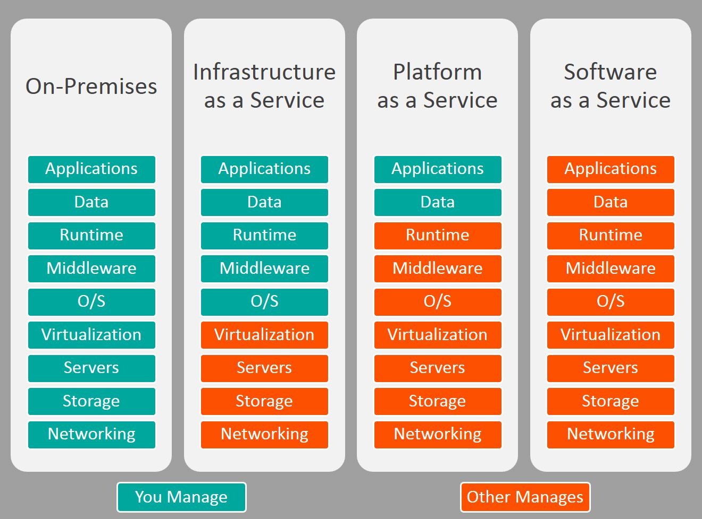

4. AWS Account Creation
Follow these steps to create your AWS account:
- Visit AWS Free Tier.
- Sign Up:
  - Enter your email address and password.
  - Create an account name.
- Account Type: Choose "Personal" or "Professional."
- Payment Method: Add a valid credit/debit card for identity verification.
- Verify Identity: Enter your mobile number for OTP verification.
- Select Support Plan: Choose "Basic (Free)."
- Log in to the AWS Management Console.
Deep Dive Knowledge:
- AWS Free Tier offers 12 months of free services like EC2, S3, and Lambda with usage limits.
- Real-time Example: Use the free tier to deploy a simple static website using S3 and monitor costs via the AWS Billing Dashboard.

Hands-On Practice
- Objective: Create an AWS account and explore the Management Console.
- Tasks:
  - Sign up for an AWS account using the steps above.
  - Navigate through the AWS Console to identify key services like EC2, S3, and RDS.
Resources
- AWS Free Tier Overview
- AWS Documentation
- Virtualization Basics
Key Takeaways
- Virtualization is the backbone of cloud computing.
- Understand the differences between IaaS, PaaS, and SaaS.
- AWS provides a user-friendly interface for cloud services.

